# Business Problem

The problem in hand is to decide the type of restaurant and neighborhood to be selected for a new business venture.

With the help of foursquare location data, the selected neighborhood data to be analyzed and clustered into different categories to have the statistical measure about the neighborhood.

Few of the key criteria should be to assess

* What type of restaurants the particular neighborhood is having
* Should the new venture follow any of the existing ones which is thriving in the neighborhood
* What are the other amenities the neighborhood is having; which may decide the type of restaurant like if a gym is nearby, more likely younger crowd is expected; which may incline to open a café rather than a proper diner place

The target audience of this business problem would be the Entrepreneurs who wish to open up restaurant or even any other facility like Gym, health clinic etc. Aspiring entrepreneurs will be having all the required data points to decide upon their idea.

# Data Section

The parameter to select the business venture will involve way lot of details and data study but for our exercise let’s consider below must have information in our data-

* Current restaurant type
* Restaurant ratings and reviews
* Transportation information like Airport or Bus service
* Other nearby venue details like
  + Hospital
  + Gym
  + Historic Site
  + Airport
  + Bus
  + School
  + Hotel/Motel
  + Shopping Mall
  + Theater
  + Metro
  + Bar/Pub

Using Four Square location data, one could get answer to all of these deciding factors. The location data will contain all the restaurant and other place information pertaining to a particular location. We need to cleanse, massage, group and cluster the information to assess above parameters to decide upon the ideal business venture for a particular neighborhood

# Methodology

The methodology section will describe the step by step process to acquire¸ cleanse and format the data to help answer the defined business problem

## Data Source

We will analyze the neighborhood of Toronto to find out the best possible location to open up a restaurant. The source of our data analysis would be from Wikipedia

<https://en.wikipedia.org/wiki/List_of_postal_codes_of_Canada:_M>'

We have extracted the neighborhood wise postal code and Borough information from this Wikipedia page and load into data frame

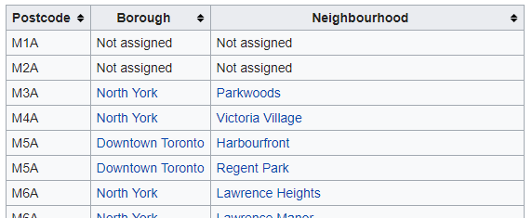

## Data Cleansing

The Raw data is to be cleaned and formatted step by step to prepare our data frame for further analysis

* Discarding the rows where Borough doesn't have any value i.e. Not Assigned
* More than one neighborhood can exist in one postal code area. For example, in the table on the Wikipedia page, M5A is listed twice and has two neighborhoods: Harbourfront and Regent Park. Combining these type of rows into one row with the neighborhoods separated with a comma

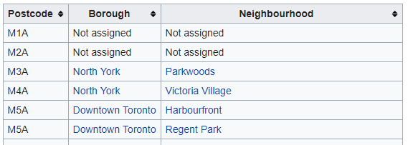

* Replacing “Neighborhood” information with “Borough” where “Neighborhood” information is missing i.e. Not Assigned



## Data Enrichment

The cleanse data is then enriched with coordinate information to fetch location data from Foursquare for our data analysis

* Read the csv file to load the postal code wise coordinates i.e. Latitude and Longitude into a Data Frame

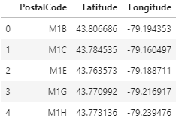

* Merge two data frames i.e. Postal Code wise Toronto neighborhood information and Postal Code wise coordinates to prepare our final Data frame

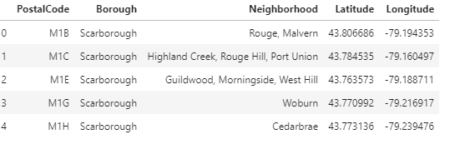

## Data Analysis

Now as we have the final Data Frame ready with Postal Code wise Location information along with their coordinates¸ we will fetch the neighborhood details using Foursquare location API and do further analysis

* Fetching the data from Foursquare and building Neighborhood wise all the venue details

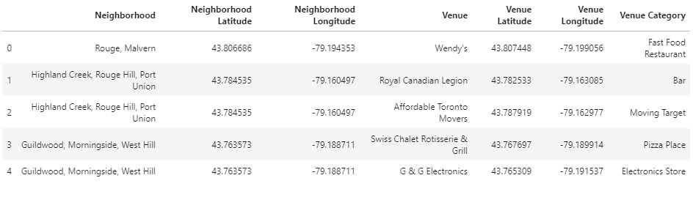

* The basic inclination would be to open up a restaurant to a location where the restaurant business has already been flourished. So we further analyzed the data to list down the Neighborhood having maximum number of any type of Restaurants

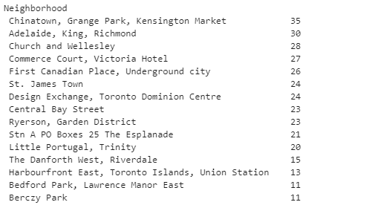

Let’s visualize the above data

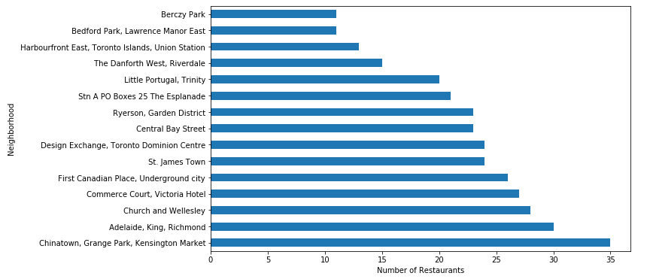

We have listed down top15 neighborhoods in Canada which has maximum no of restaurants where highest no of restaurants are being in Chinatown¸ Grange Park neighborhood which has 35 restaurants and next to list is Adelaide King which has 30 restaurants

* The one of the key factors that we have decided in our business problem to identify the most visited neighborhood i.e. neighborhood having other venues like Gym¸ Shopping Malls¸ Theater etc. which attracts more people to visit thus having restaurant in those neighborhood will ensure more footfall into the restaurant

Let’s analyze the neighborhood which having below amenities-

* + Hospital
  + Gym
  + Historic Site
  + Airport
  + Bus
  + School
  + Hotel/Motel
  + Shopping Mall
  + Theater
  + Metro
  + Bar/Pub

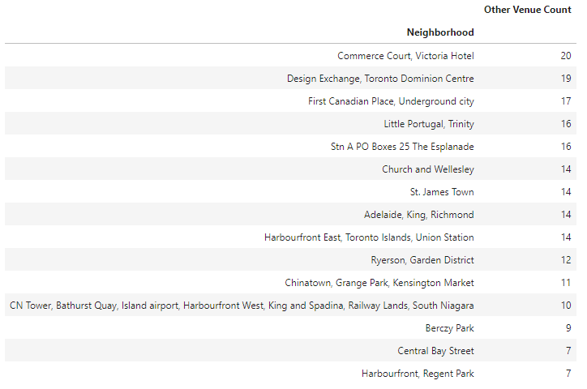

* Now to decide upon the restaurant location¸ we need to consider the neighborhood having mix of both i.e. the location to already have good amount of restaurant which will make it a good choice to open another one and also the neighborhood has other key venues which will bring more people to that neighborhood thus ensuring more influx of footfall into the restaurant

Let’s visualize the top 15 neighborhood considering both restaurant and other venue count

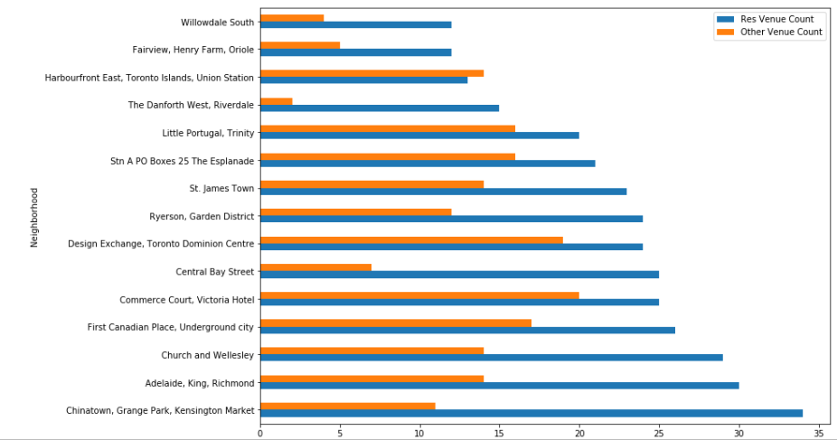

* We need to strike a balance between the neighborhoods which has maximum no of restaurants vs the one having most number of other venues. One shouldn’t choose a location where the restaurant count has already reached its limit and opening up another one will lead to competing with already established joints and a very low footfall due to less people being around that neighborhood. On the other hand¸ places where quite a few other venues are there but not much restaurants that means people are either eating at those very venues (like Mall) or they are around for very short period of time (like Bus Station). So opening up a new restaurant in those places will not be beneficial.

So for our business problem we will take the average count of the restaurants and other venues for each neighborhood and decide further.

Let’s visualize the data

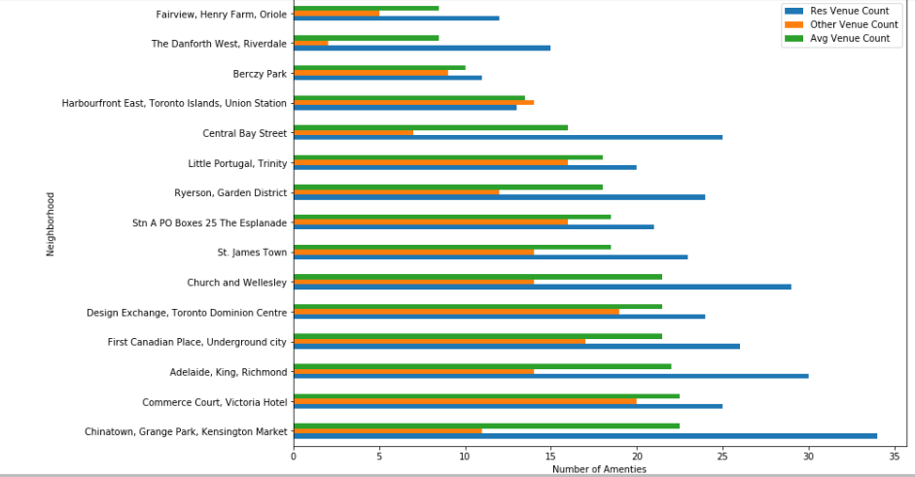

# Result

From the Data Analysis phase, we have been able to drill into top 15 neighborhoods of Toronto where the maximum number of restaurants and other key venues are situated. Our consideration is to decide upon a neighborhood where both restaurants and other venues are there and the place is not skewed to particular type i.e. either it has too many restaurants or too many other venues with not many restaurants.

The key findings from our data analysis are-

* Chinatown Grange Park has maximum no of restaurants(34) but neighborhood has very low no of other venues (11)



* Commerce court neighborhood has maximum no of other venues but restaurant count is comparatively low



* Harbourfront East ¸ Design Exchange and Stn A PO Boxes neighborhoods seem to have near equal ratio of number of restaurant and other venues

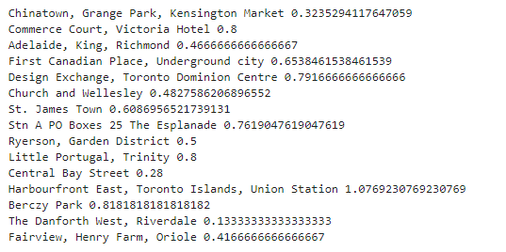

# Discussion

From our data analysis and result findings¸ possible choice of Neighborhood for a new restaurant could be any of below three-

1. Commerce Court¸ Victoria Hotel
2. Design Exchange¸ Toronto Dominion Centre
3. Harbourfront East¸ Toronto Islands¸ Union Station

Let’s re look of the venue count of these neighborhoods-

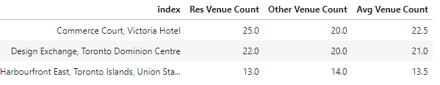

By looking at the venue count of restaurants and others of these 3 major neighborhood and the count ratio among them “Design Exchange¸ Toronto Dominion Centre” seems to be the most appropriate choice for opening up a new restaurant.

Let’s check all the current restaurant and other venue details of “Design Exchange” neighborhood-

**Restaurant Details**

|  |  |  |
| --- | --- | --- |
| **#** | **Venue** | **Venue Category** |
| 3 | Cactus Club Cafe | American Restaurant |
| 13 | Jack Astor's Bar & Grill | American Restaurant |
| 11 | Bosk at Shangri-La | Asian Restaurant |
| 15 | iQ Food Co | Fast Food Restaurant |
| 16 | Biff's Bistro | French Restaurant |
| 4 | Kupfert & Kim (First Canadian Place) | Gluten-free Restaurant |
| 17 | Estiatorio Volos | Greek Restaurant |
| 8 | Amano Pasta | Italian Restaurant |
| 20 | Scaddabush Italian Kitchen & Bar | Italian Restaurant |
| 21 | TOCA | Italian Restaurant |
| 2 | Ki Modern Japanese + Bar | Japanese Restaurant |
| 19 | Fune Japanese Restaurant | Japanese Restaurant |
| 22 | The Chase | New American Restaurant |
| 1 | Canoe | Restaurant |
| 5 | Bymark | Restaurant |
| 6 | Marché Mövenpick | Restaurant |
| 7 | Kellys Landing | Restaurant |
| 9 | John & Sons Oyster House | Seafood Restaurant |
| 12 | Buster's Sea Cove | Seafood Restaurant |
| 18 | John & Sons Oyster House | Seafood Restaurant |
| 10 | Ruby Thai (First Canadian Place) | Thai Restaurant |
| 14 | Rosalinda | Vegetarian / Vegan Restaurant |

**Other Venue Details**

|  |  |  |
| --- | --- | --- |
| **#** | **Venue** | **Venue Category** |
| 6 | Earls Kitchen & Bar | Bar |
| 11 | Boxcar Social Temperance | Bar |
| 15 | Loose Moose | Bar |
| 4 | WVRST | Beer Bar |
| 13 | Craft Beer Market | Beer Bar |
| 8 | Piper's Gastropub | Cocktail Bar |
| 1 | Equinox Bay Street | Gym |
| 5 | Adelaide Club Toronto | Gym / Fitness Center |
| 2 | The Fairmont Royal York | Hotel |
| 12 | The Adelaide Hotel Toronto | Hotel |
| 14 | Shangri-La Toronto | Hotel |
| 16 | The Ritz-Carlton | Hotel |
| 18 | Le Germain Hotel | Hotel |
| 19 | Hilton Toronto | Hotel |
| 20 | Cosmopolitan Toronto Centre Hotel & Spa | Hotel |
| 7 | Library Bar | Hotel Bar |
| 3 | Walrus Pub & Beer Hall | Pub |
| 10 | Brookfield Place | Shopping Mall |
| 17 | Royal Alexandra Theatre | Theater |
| 9 | The National Club | Wine Bar |

As we can see the “Design Exchange” neighborhood has variety of restaurants and quite a good mix of other venues especially Gym¸ Hotel¸ Shopping Mall and Theater which will ensure good influx of different type of people in the neighborhood e.g. younger lot is expected in Gym¸ Aristocrats and tourists are expected due to hotels¸ family is expected due to Shopping Mall and Theater etc.

# Conclusion

The location selection for a restaurant depends on multiple other minute and important criteria like life style of the neighborhood (i.e. Rich¸ Middle class or upper middle class)¸ likely age group of the neighborhood (i.e. Teen¸ Middle age) ¸cost of the place (either buy or rent)¸ Transportation for raw materials etc.

In our business problem and leading up to the data analysis and discussion we have kept our approach very simple and tried to minimize our scope with respect to data availability.

We have tried to depict a very realistic business problem and proposed a simplistic approach to solve or answer that. We have used the data available in Web. The basic neighborhood data is collected from Wikipedia and detail level neighborhood wise venue information is collected through Foursquare Location API. The data is cleansed¸ enriched and formatted for the data analysis. As per the solution¸ main key point that we have decided upon is to find out the neighborhood

* + Which already has good number of restaurants
  + Which has quite a few other key venues
  + And the ratio of restaurant and the other venue count should be proportionate.

We have started with basic data frame and continued exploring the data to find out the answer to above points and concluded the most appropriate neighborhood to open up a new restaurant.